# How to Replace Battery

For 280T-S

1. Remove the screws in the back of the transmitter.

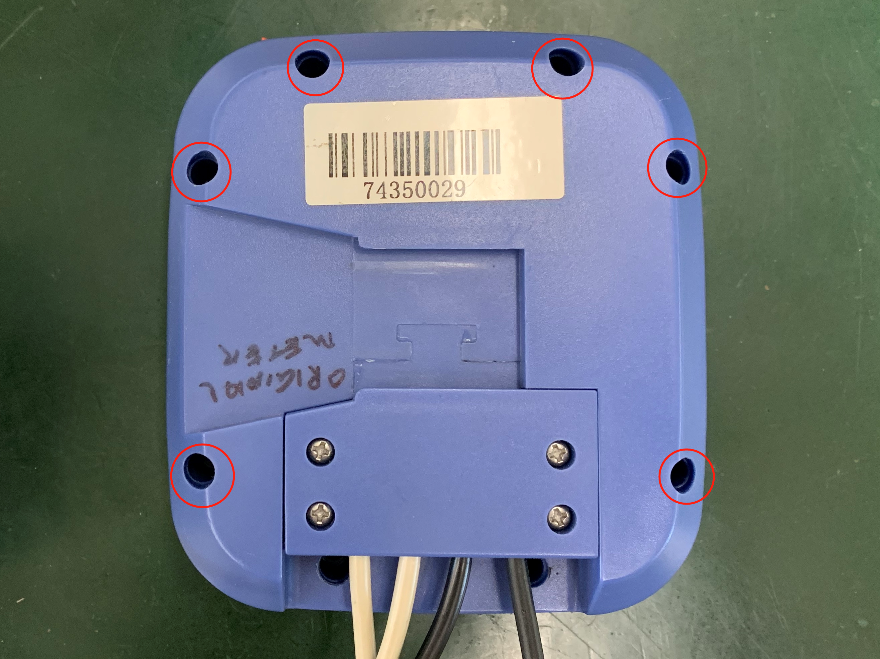

1. Open the front panel. Remove the screws holding PCB and unplug the battery connector.

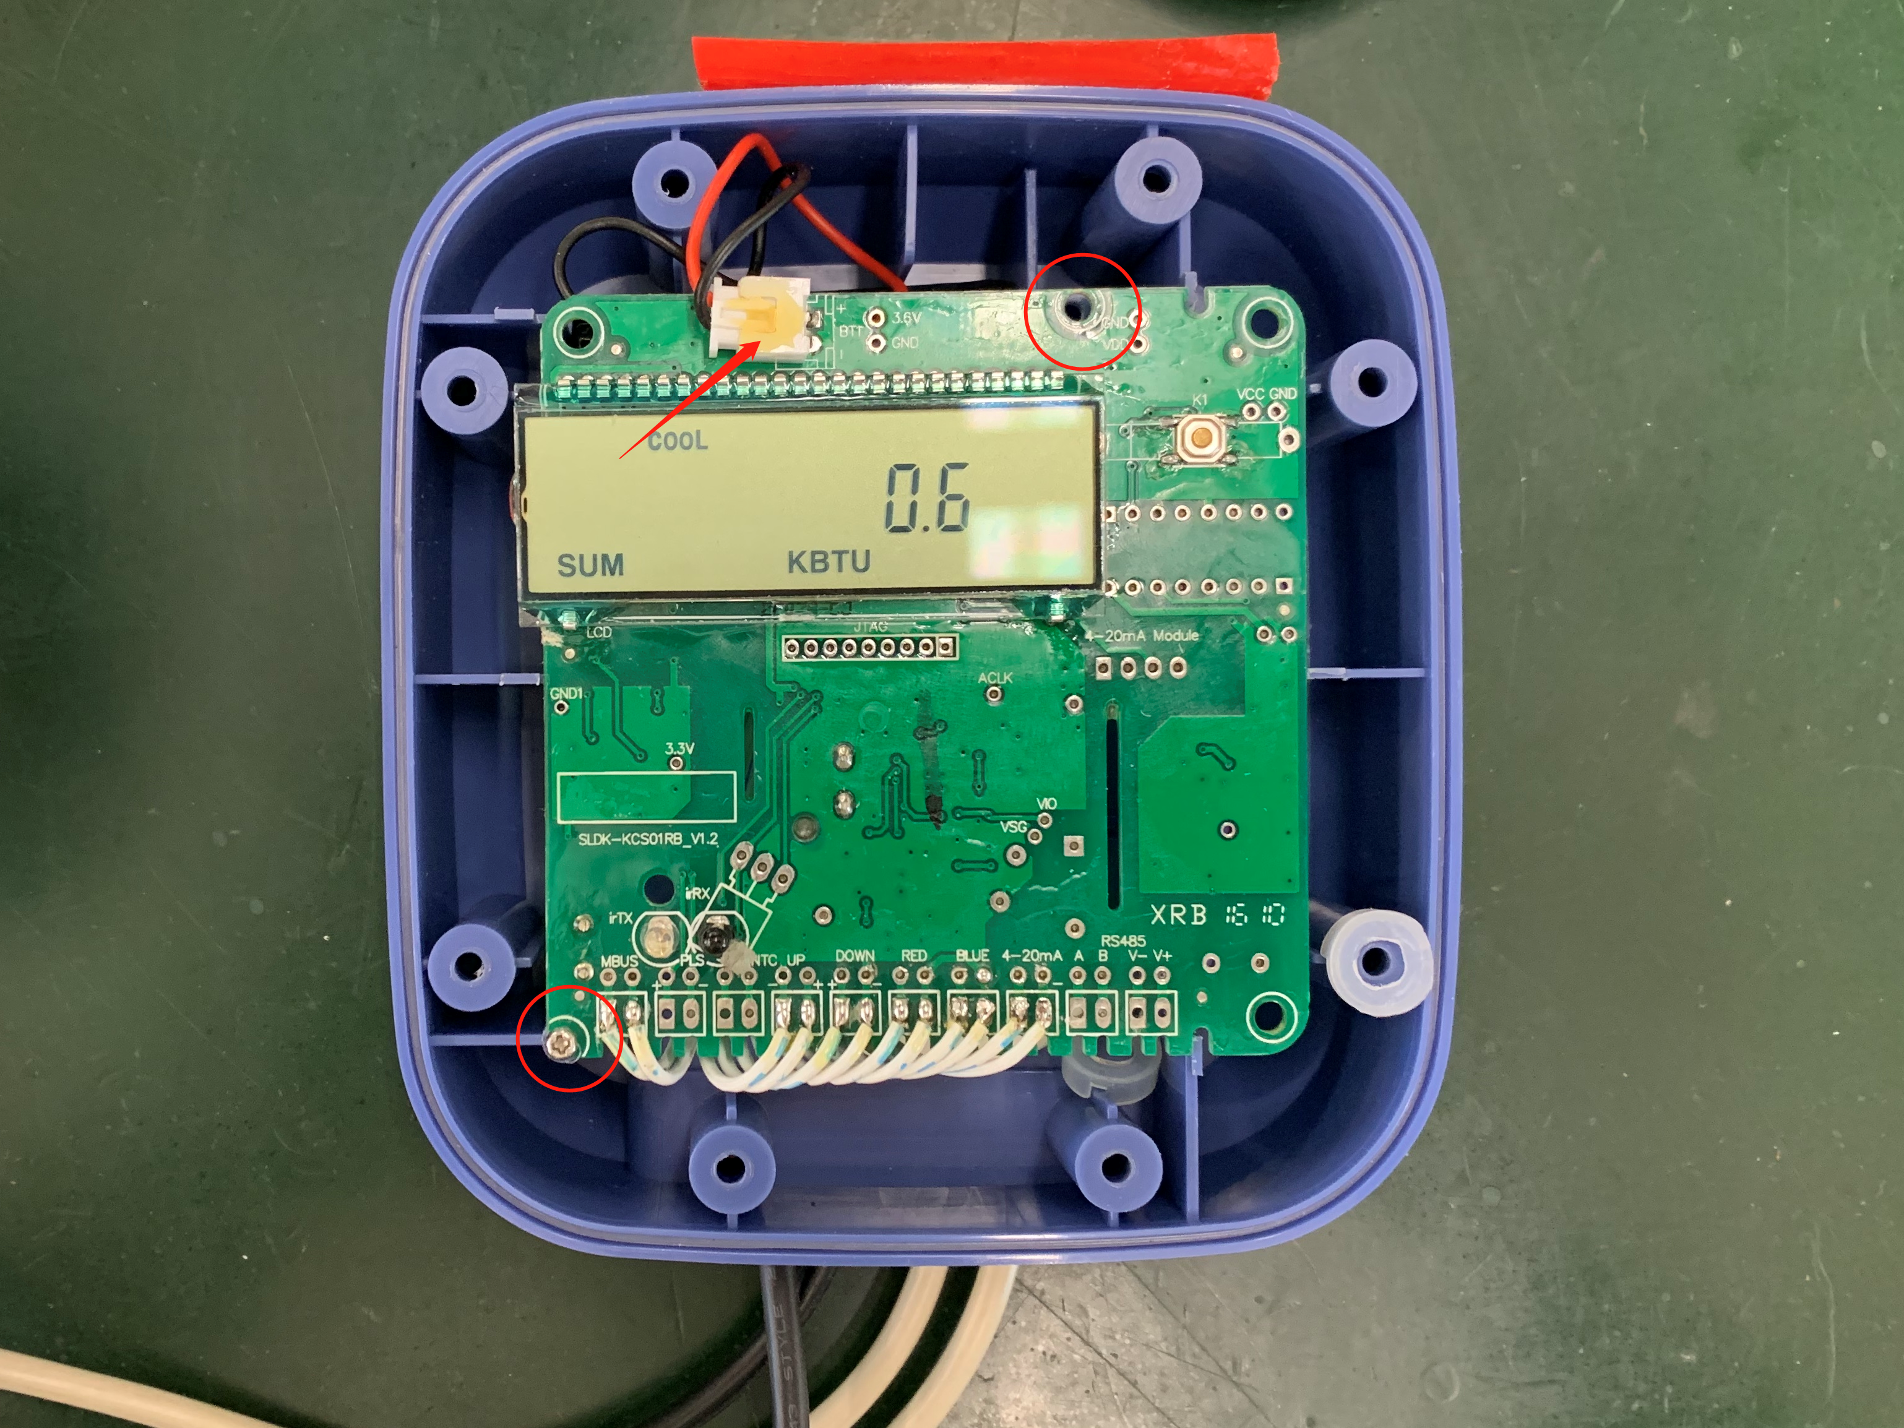

1. Lift PCB carefully. Remove the old battery and install new battery.

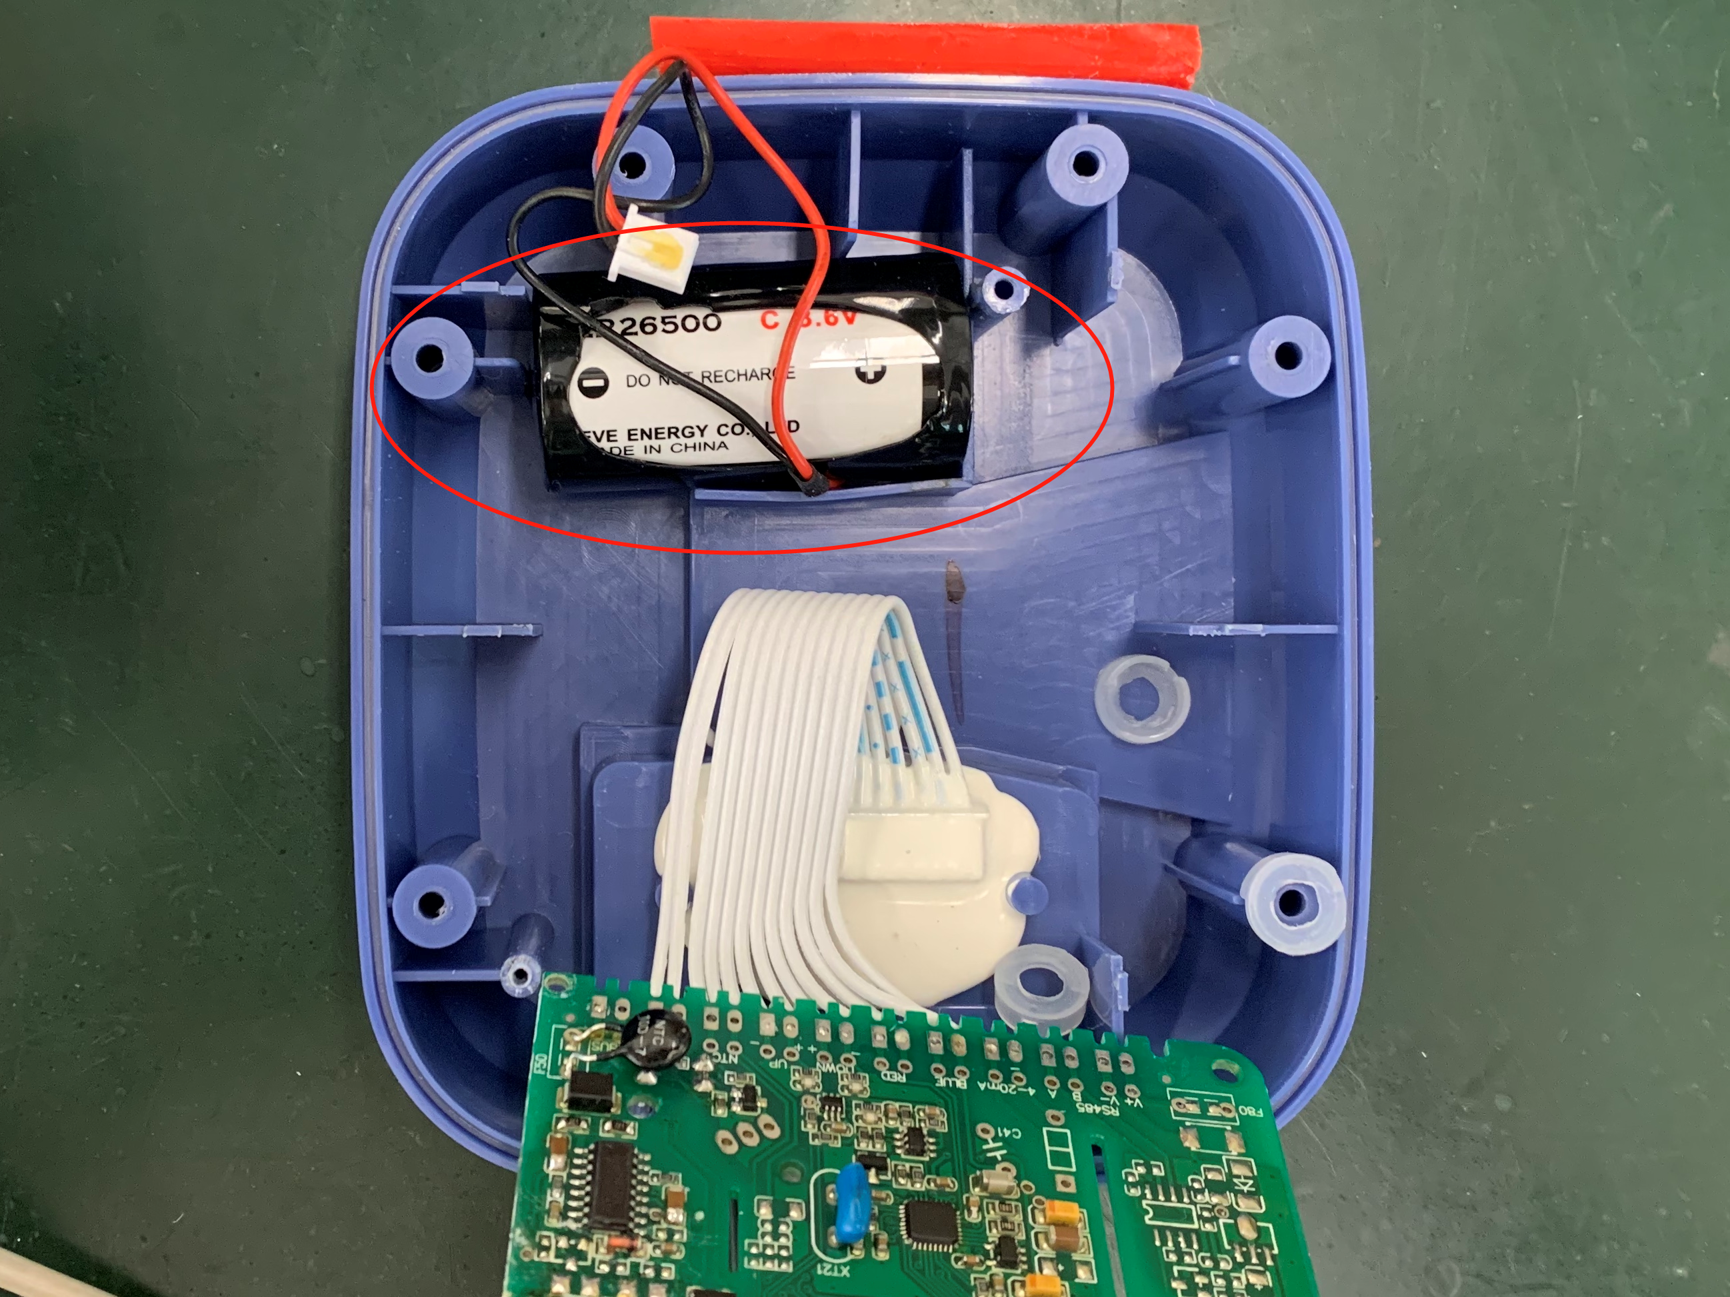

1. Replace PCB and all screws. Make sure no wires are pinched.